

|  |  |  |  |
| --- | --- | --- | --- |
| Year 11 Human Biology – Extended Response (Task 6)  **Digestive and Excretory System - Digestive System (3%)** | | | |
|  | | | |
| Name: | | | |
| Time allowed: 1 Lesson | | | |
| **Section** | Your Mark | Marks available | Percentage of Investigation |
| **Section 1:**  The Journey of a Piece of Food |  | 25 | 50% |
| **Section 2**:  Validation Test |  | 25 | 50% |
|  |  | **50** | **100%** |

**Declaration of Authenticity**

I (Student Name) _____________________ declare that this work is my own and I have not plagiarised from any source.

Signature:  
  
Date:

**Section 1: The Journey of a Piece of Food**

**Task:**

Choose one item of food. It must be a solid food, not a drink.

Describe the journey of this piece of food throughout the entire digestive system.

**Make sure to describe:**

* The entire process, from ingestion to elimination.
* How long it takes for each stage of the process
* The mechanical digestive of the food
* The chemical digestive of the food
* The substances that are broken down and absorbed from the specific type of food you chose
* What those substances are then used for in the body

**Your assignment must follow the following guidelines:**

* It must be no more than 1000 words.
* It must include references in APA style format at the end of the assignment (you are expected to use at least two sources, other than your textbook for this task). The references do not count towards your word count.
* You must use appropriate headings to break your assignment.

**Other allowances:**

* Please be aware that you are allowed and encouraged to use diagrams to support your assignment, however if you do please include a link to those images in the document as a reference.

Most marks will be associated with the quality and accuracy of your description of the process. However, some marks are associated with the format of your assignment and its readability. *(Hint: using appropriate headings and avoiding complicated jargon will improve your assignment)*

**Due Date:**

*Section 1: The Journey of a Piece of Food*  
Is to be submitted via connect by Monday 13th May 9:00pm.

*Section 2: Validation Test*   
Will take place in class on Tuesday 14th May (Tuesday Week 3)

**Section 1:** The Journey of a Piece of Food – Marking Rubric

***Marks Description:***

|  |  |  |
| --- | --- | --- |
| **Level** | **Score** | **Description** |
| Not Discussed | 0 | Little to no information about this is provided |
| Developing | 1 | Information lacks detail or contains information that is incorrect. |
| Satisfactory | 2 | Information is correct and clear, however additional information was needed. |
| Exemplary | 3 | Information is detailed and includes all the relevant facts |

**Main Content:** **(21 Marks)**

|  |  |  |
| --- | --- | --- |
| **Area of the Digestive System** | **Information**  **Required** | **Scored**  **(0-3)** |
| Mouth and Oesophagus | Describes the role of the mouth, teeth, salivary glands, epiglottis and esophagus in digestion. |  |
| Stomach | Describes the role of the stomach in mechanical digestion of food, and if applicable, chemical digestion of proteins. |  |
| Small Intestine  (Breakdown) | Describes the role of the small intestine in the chemical digestion of food. Includes reference to the roles of the pancreas and if applicable the gall bladder. |  |
| Small intestine  (Absorption) | Describes how substances are absorbed in the small intestine, referring to the villi and microvilli and processes of transportation of the specific nutrients. |  |
| Material breakdown and use. | Describes what the specific substances in the chosen food are broken down into, and what they are used for in the body. |  |
| Large intestine | Describes the role of the large intestine in the absorption of water, minerals and some vitamins. Also discusses the role of bacteria in the breakdown of materials. |  |
| Elimination and Faeces | Describes the process of elimination from the rectum and anus. Discusses the make-up of faeces. |  |
| **Total** | |  |

**Presentation and Format: (3 Marks)**

|  |  |  |
| --- | --- | --- |
| **Developing (1)** | **Satisfactory (2)** | **Exemplary (3)** |
| Assignment is not written in a logical order, or lacks structured paragraphs/headings. Scientific vocabulary is not used very often, or is used incorrectly. | The assignment is written in a fairly logical order. Some headings and paragraphs could have been better structured. Correct scientific vocabulary is used sometimes. | Assignment is written in a logical order, with use of headings, and paragraphs to break up content. The assignment is clearly written and correctly uses scientific vocabulary. |

**References: (1 Mark)**

Included 3 references in APA formatting ☑ ☒

**TOTAL: /25**



|  |  |  |  |
| --- | --- | --- | --- |
| Year 11 Human Biology – Extended Response (Task 6)  **Digestive and Excretory System - Digestive System (3%)** | | | |
|  | | | |
| Name: | | | |
| Time allowed: 1 Lesson | | | |
| **Section** | Your Mark | Marks available | Percentage of Investigation |
| **Section 1:**  The Journey of a Piece of Food |  | 25 | 50% |
| **Section 2**:  Validation Test |  | 25 | 50% |
|  |  | **50** | **100%** |

**Extended Response Validation Test:**

1. Finish labelling the following diagram of the digestive system. (3 marks)

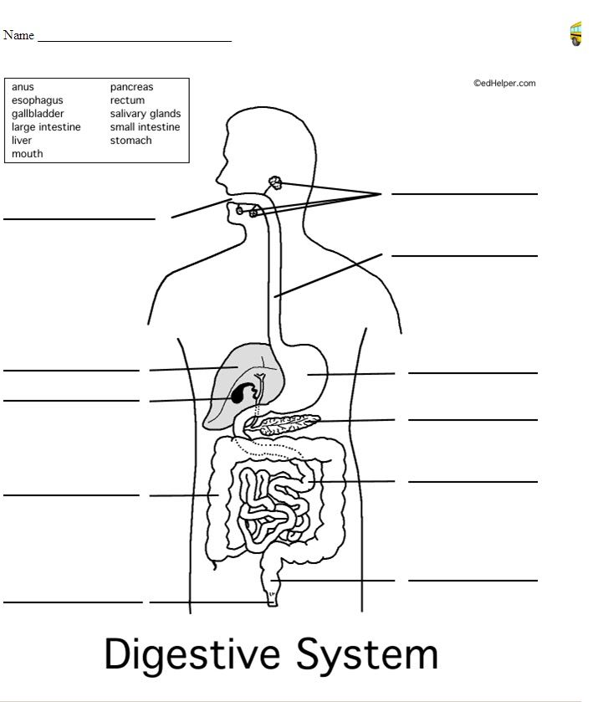

1. Mouth Cavity
2. Liver
3. Gall Bladder
4. Large Intestine
5. Anal Sphincter
6. Salivary Glands
7. Oesophagus
8. Stomach
9. Pancreas
10. Small Intestine
11. Rectum
12. Explain the role of the following parts of the digestion system on the digestion of food. (14 marks)

|  |  |
| --- | --- |
| **Part** | **Role in digestion of foods** |
| C  3 marks | * Releases bile into the duodenum (small intestine) * This emulsifies (breaks the fat up into small droplets) * It increases the surface area for lipases to break down the fats. * Secretes bicarbonate ions to neutralize acid from chyme |
| F  4 marks | * Salivary glands secrete saliva into the mouth cavity. * It helps to hold the food in a lump (bolus) for swallowing * It lubricates the mouth and food for swallowing * It contains amylase, which begins the break down of starch (carbohydrates) |
| I  5 marks | * Secretes pancreatic juice into the duodenum (small intestine) which contains: * Pancreatic amylase – breaking down starch * Pancreatic protease – breaks down proteins * Pancreatic lipases – break down lipids * Nucleases – breaks down DNA & RNA * Releases bicarbonate ions that neutralie the HCl in the chyme |
| K  2 marks | * Stores the faeces * Trigger the defecation response |

1. To be effective, any surface where materials are taken into the body, or passed out of the body must have a very large surface area. Explain how a large surface area is achieved in the part of the digestive system where nutrients are absorbed. (4 marks)

The small intestine is where absorption occurs.

* It is very long
* The inner lining (mucosa) is folded
* The mucosa has small finger like projections called villi that extend into the small intestine
* The villi are covered in cells that have microvilli, tiny microscopic projections on their external surface

1. Substances that humans eat have to be broken down into smaller substances to be absorbed by the human body. Choose one of the following substances and state what enzyme is used to break it down, where this occurs in the digestive system, what it is broken down into, and what it is used for in the body. (4 marks)
   * Lipids
   * Proteins
   * Carbohydrates
   * DNA/RNA

|  |  |  |  |  |
| --- | --- | --- | --- | --- |
| Substance | Enzyme | Part | Broken down into | Use |
| Proteins | Protease (Pepsin/trypsin) | Stomach and Small Intestine | Amino Acids | Create new proteins |
| Carbohydrates | Amylase | Mouth and small intestine | Simple Sugars | Energy for cells |
| Lipids | Lipase | Small intestine | Fatty acids + Glycerol | Energy for cells |
| DNA/RNA | Nuclease | Small intestine | Nucleotides | Creating new DNA/RNA |